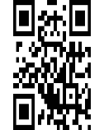

Tabassum

Md Jakir Hussain

2 NOV 2004

FEMALE

FEMALIE

6666 7777 4444

[This Photo](https://www.pngall.com/qr-code-png/) by Unknown Author is licensed under [CC BY-NC](https://creativecommons.org/licenses/by-nc/3.0/)

